**FINAL REPORT**

Felia Azahra 14117072, Irma Safitri 14117067, Nurtias Rahayu 14117086,

Nurul Fauzia Azizah 14117071

*Informatic Engineering*

*Jurusan Teknologi Produksi dan Industri*

*Institut Teknologi Sumatera*

*South Lampung, Lampung, Indonesia*

Abstract— Global warming that currently happens in Indonesia, is causing the change of seasons becomes not stabilized. It makes between dry season and rainy season were could not be predicted anymore. No wonder, in the dry season, the rain could fall suddenly. This condition would distressing when it comes to drying up the clothes. The concern increased when the house is empty, while the wet clothes still at the outside. So, the clothes that were hanged on, could not dry up as well, and at worst they could become dirtier then caused a not-good-smell. To solve the problems, was made a design of automatic clothesline that based on arduino. This automatic clothesline works when the lght sensor and raindrop censor could predict the change of seasons around. And the result of those censors is processed by arduino, which is used to pull off and pull out the clothesline using the Servo Motor.

**Keywords**— Arduino, Light Sensor, Raindrop Sensor, Clothesline.

1. INTRODUCTION
   1. Background of Problems

Collegers are literally people who study in colleges, both at universities, institutes and academies. In the Indonesian Language Dictionary (2008), the definition of a colleague is a person who studies in college. Those who are registered as students in tertiary institutions can be called tertiary institutions (Takwin, 2008).

Indonesian collegers are scattered in various colleges in the country, many collegers study in the areas where they come from and many also migrate to big cities where be favorite colleges. Wander off is a something new for collegers, because they no longer live with their parents but boarding house or boarding at the college where they are. Overseas collegers are required to do all aspects of life independently, such as washing clothes, washing dishes, cleaning rooms, and other.

In the case of washing clothes, collegers often mess around with drying clothes after washing. When drying clothes, it is not often for collegers who are preoccupied with activities on campus to forget the clothes they are drying, the result is if the rain suddenly comes the clothes did not have time to be appointed and become wet again. If it's like this the collegers will be hassles, eespecially if the supply of clothes begins to thin. Actually collegers can loundry their clothes, but for some collegers whose money from their parents is barely enough it would be thrifty to wash their own clothes.

Therefore it is need to be a problems solving, by making a tool "Jemuran Anak Kosan Otomatis" which can be called JAKO. This automatic clothesline is expected to help collegers stay focused on campus activities without thinking about the clothes they are drying in the boarding house. Aside from that, JAKO is relatively inexpensive and in line with the overseas collegers budget.

* 1. Problem Space

How to make automatic clothesline using light sensor and water sensor?

* 1. The Purpose of System Design

1. Complete a large assignment in the Embedded system course
2. Make it easier for people who are more often outside the house in terms of taking care of clotheslines.
3. literatur review

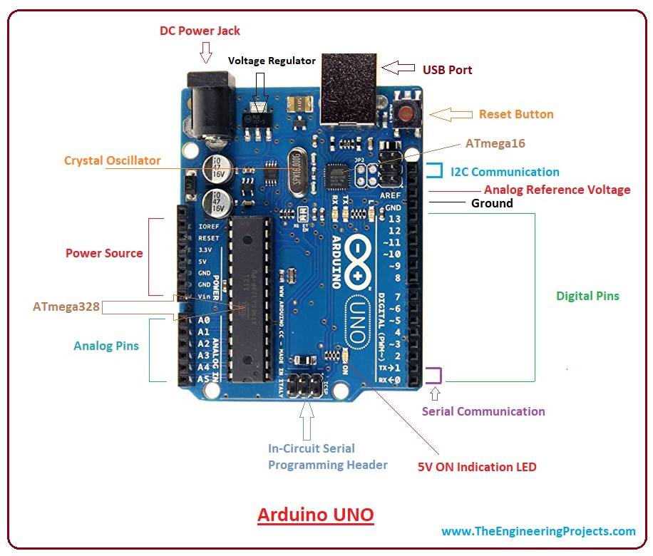

**Image 1. Arduino**

Arduino is an open-source electronics platform based on easy-to-use hardware and software. [Arduino boards](https://www.arduino.cc/en/Main/Products) are able to read inputs - light on a sensor, a finger on a button, or a Twitter message - and turn it into an output - activating a motor, turning on an LED, publishing something online. You can tell your board what to do by sending a set of instructions to the microcontroller on the board. To do so you use the [Arduino programming language](https://www.arduino.cc/en/Reference/HomePage) (based on [Wiring](http://wiring.org.co/)), and [the Arduino Software (IDE)](https://www.arduino.cc/en/Main/Software), based on [Processing](https://processing.org/).

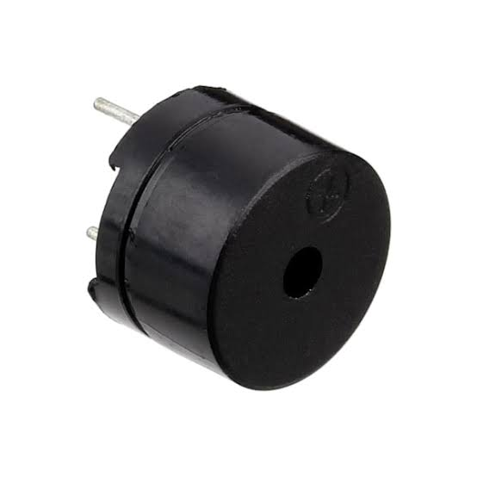

Image 2. Buzzer

**Piezo buzzer** is an electronic device commonly used to produce sound. Light weight, simple construction and low price make it usable in various applications like car/truck reversing indicator, computers, call bells etc. Piezo buzzer is based on the inverse principle of piezo electricity discovered in 1880 by Jacques and Pierre Curie. It is the phenomena of generating electricity when mechanical pressure is applied to certain materials and the vice versa is also true. Such materials are called piezo electric materials. Piezo electric materials are either naturally available or manmade. Piezoceramic is class of manmade material, which poses piezo electric effect and is widely used to make disc, the heart of piezo buzzer. When subjected to an alternating electric field they stretch or compress, in accordance with the frequency of the signal thereby producing sound.

IOT describes about connecting the physical devices with the sensors to the Internet, via wired or wireless networks. These sensors can use various types of local area connections like RFID, NFC, Wi-Fi, Bluetooth, and Zigbee. Sensors can also have wide area connectivity such as GSM, GPRS, 3G, and LTE.

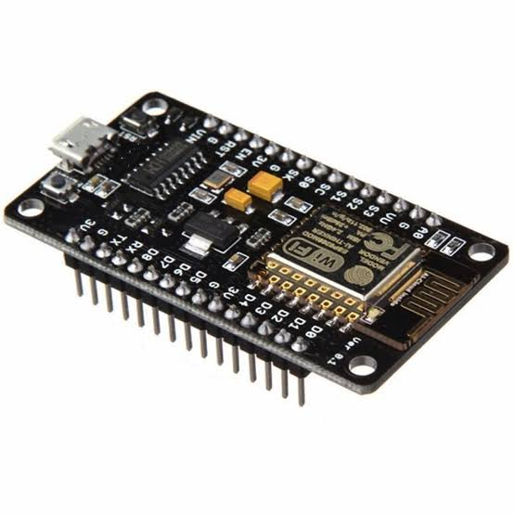

Image 3. ESP8266

The ESP8266 WiFi Module is a self contained SOC with integrated TCP/IP protocol stack that can give any microcontroller access to your WiFi network. The ESP8266 is capable of either hosting an application or offloading all Wi-Fi networking functions from another application processor. Each ESP8266 module comes pre-programmed with an AT command set firmware. The ESP8266 module is an extremely cost effective board with a huge, and ever growing, community.

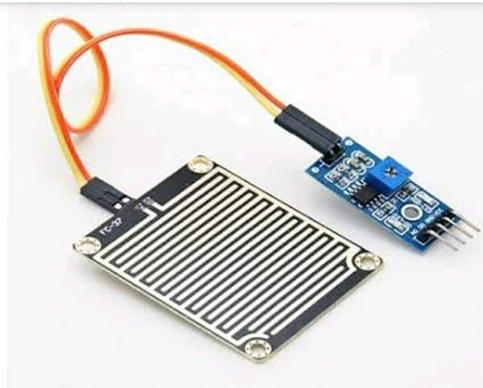

Image 4. Raindrop Sensor

**A raindrop sensor is a device used in the detection of the water level for various applications. Water sensors can come in several variations that include ultrasonic sensors, pressure transducers, bubblers, and float sensors.** Water sensor brick is designed for water detection, which can be widely used in sensing rainfall, water level, and even liquid leakage. Connecting a water sensor to an Arduino is a great way to detect a leak, spill, flood, rain, etc. It can be used to detect the presence, the level, the volume and/or the absence of water. While this could be used to remind you to water your plants, there is a better Grove sensor for that. The sensor has an array of exposed traces, which read LOW when water is detected.

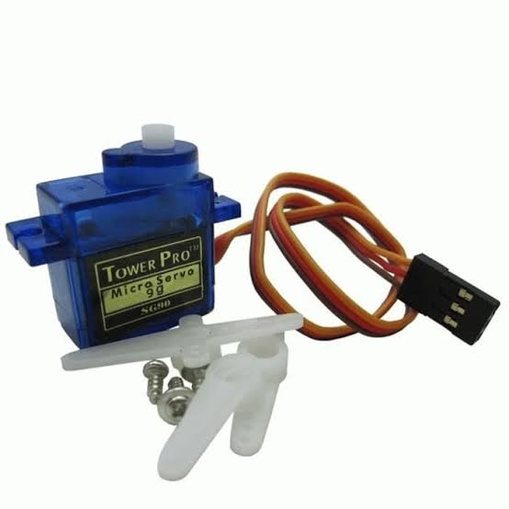

Image 5. Servo Motor

**Servo is a general term for a closed loop control system. A closed loop system uses the feedback signal to adjust the speed and direction of the motor to achieve the desired result. The potentiometer provides position feedback to the servo control unit where the current position of the motor is compared to the target position. According to the error, the control unit corrects the actual position of the motor so that it matches the target position.**

1. RESULT AND ANALYSIS
   1. Tool’s Name

The tool we made is named "Jemuran Anak Kosan Otomatis".

* 1. Tool description

JAKO a tool to facilitate household chores on clothes drying. This tool is relatively simple with a fairly simple manufacture too. Therefore, its use is very helpful, especially for collegers, employees, and others. JAKO utilizes a light sensor system, a simple rainwater sensor system and a clothesline driving servo motor.

* 1. Cost

Table 1. Cost

|  |  |  |  |
| --- | --- | --- | --- |
| Num | Item’s Name | Amount | Price |
| 1. | Arduino Uno | 1 Unit | Rp. 85.000,- |
| 2. | Kabel Jumper | 2 Unit | Rp. 10.000,- |
| 3. | Sensor KY-006 Passive Buzzer | 1 Unit | Rp. 31.000,- |
| 4. | Light Sensor | 1 Unit | Rp. 8.700,- |
| 5. | Raindrop Sensor | 1 Unit | Rp. 12.000,- |
| 6. | Motor Servo | 1 Unit | Rp. 30.000,- |
| 7. | ESP8266 Wi-Fi Module | 1 Unit | Rp. 46.999,- |
| 8. | Resistor 220 ohm | 1 Unit | Rp. 200,- |
| 9. | Breadboard | 1 Unit | Rp. 12.000,- |
| TOTAL | | | Rp. 235.899,- |

* 1. Flowchart

Flowchart is a picture shows the flow of processes and relationships from one process to another within a program. Flowchart used to explain the program flow made so that anyone can understand the process of the tool.

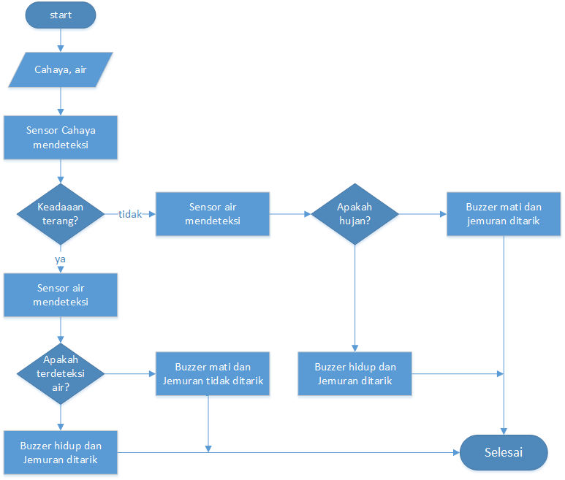

Image 6. Flowchart

* 1. Procedure

The automatic tool system consists of 4 main parts, there is:

1. Input (raindrop sensor and light sensor) : this section is the first step to provide input for processing in the controller block.
2. Controller : this section functions to process data that has been sent from input, which will then be displayed on the output.
3. Servo Motor Driver to drive the Servo Motor
4. Output (Servo Motor) : this section is the output of the data that comes in and that has been processed as the final result of the system.

D:\FILE KULIAH IRMA\ABSEN PKS\MODUL 9\blog diagram.jpg

Image 7. Block Diagram

The design of this automatic clothesline as shown in the picture above, which includes light sensor and raindrop sensor, controller, and driver Servo Motor and Servo Motor. From the picture above explained that the microcontroller is used as a controller tools, if there is a change in the condition of the input, Arduino will execute and output the result.

* 1. Image Tool
* Set of Tools

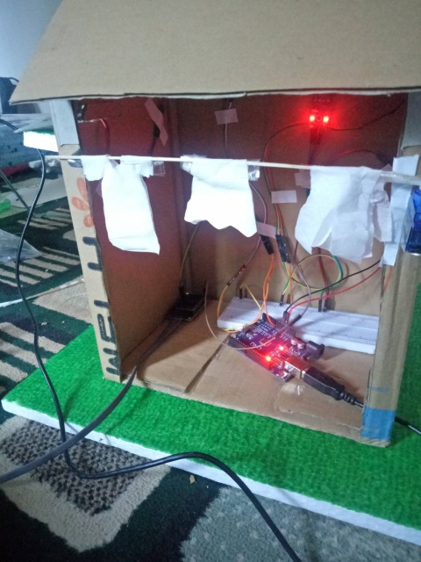

Image 8. Front View

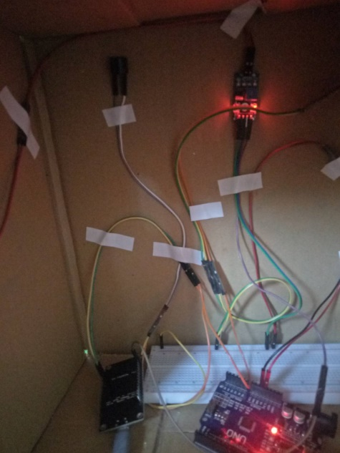

Image 9. Tools

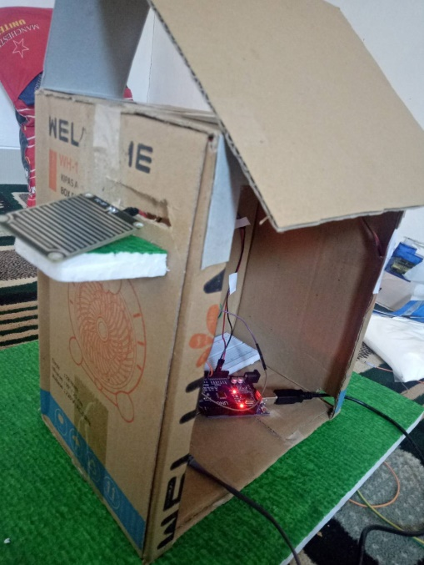

Image 10. Top View

* Connect to Cold:

1. Device ( ESP8266JAKO)

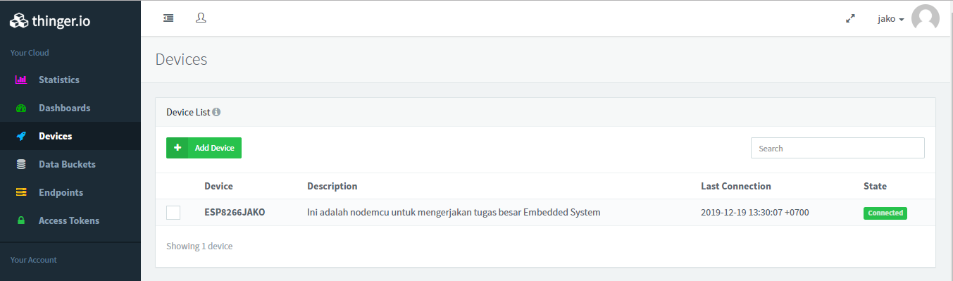

Image 11. Device

1. Dashboard (view_jako)

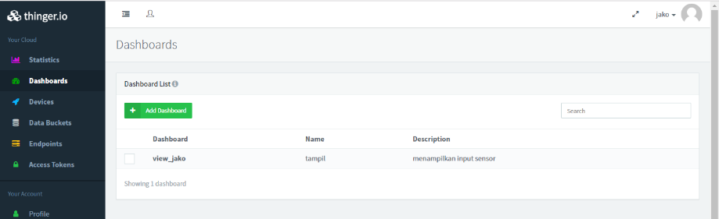

Image 12. Dashboard

1. Data Bucket (jakojako)

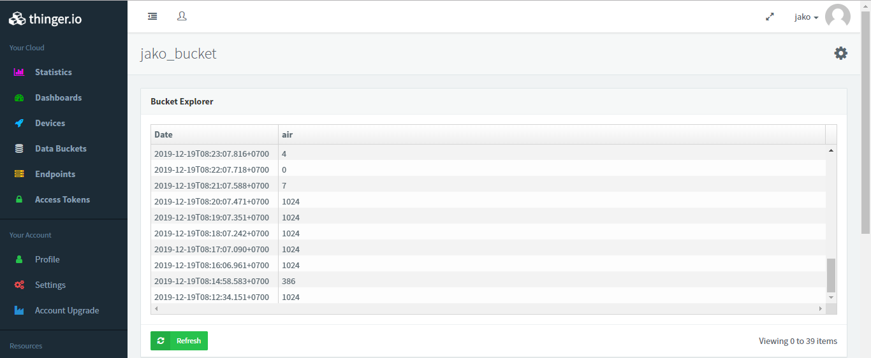

Image 13. Data Bucket

* 1. Source Code
* Setting NodeMCU

1. #include <ESP8266WiFi.h>
2. #include <ThingerESP8266.h>
4. #define USERNAME "jako" //Username thinger.io
5. #define DEVICE_ID "ESP8266JAKO"
6. #define DEVICE_CREDENTIAL "jakojako"
8. #define SSID "xyza"
9. #define SSID_PASSWORD "1sampek19"
11. ThingerESP8266 thing(USERNAME, DEVICE_ID, DEVICE_CREDENTIAL);
13. #include <Servo.h>
14. Servo myservo;
16. **const** **int** sensorMin = 0;
17. **const** **int** sensorMax = 1024;
18. **int** pos = 0;
19. **int** position_target = 1;
20. **int** position_last_set = 0;
21. **int** rangeAwal = 0;
22. **float** vout;
24. **void** setup() {
25. //Thinger.io
26. pinMode(A0,INPUT);
27. myservo.attach(5);
29. Serial.begin(115200);
31. Serial.print("Connecting to ");
32. Serial.println(SSID);
34. **while** (WiFi.status() != WL_CONNECTED) {
35. delay(500);
36. Serial.print(".");
37. }
38. Serial.println("");
39. Serial.println("WiFi connected");
41. thing.add_wifi(SSID, SSID_PASSWORD);
43. thing["inputan"] >> [](pson& out){
44. out["air"] = vout;
45. };
46. }

* Void Setup

1. **void** setup() {
2. //Thinger.io
3. pinMode(A0,INPUT);
4. myservo.attach(5);
6. Serial.begin(115200);
8. Serial.print("Connecting to ");
9. Serial.println(SSID);
11. **while** (WiFi.status() != WL_CONNECTED) {
12. delay(500);
13. Serial.print(".");
14. }
15. Serial.println("");
16. Serial.println("WiFi connected");
18. thing.add_wifi(SSID, SSID_PASSWORD);
20. thing["inputan"] >> [](pson& out){
21. out["air"] = vout;
22. };
23. }

* Void Loop

1. **void** loop() {
2. thing.handle();
4. vout = analogRead(A0);
5. **int** range = map(vout, sensorMin, sensorMax, 0, 2);
7. **if**(rangeAwal != range){
8. **if**(range==0){
10. Serial.println("Hujan");
11. **if** (position_target == position_last_set){
12. **for** (position_target = 120; position_target >= 1; position_target -= 1){
13. myservo.write(position_target);
14. delay(50);
15. }
16. position_target= position_last_set;
17. } delay(500);
18. rangeAwal = range;
19. } **else** {
20. Serial.println("Tidak Hujan");
21. **if** (position_target != position_last_set){
22. **for** (position_target = 1; position_target <= 120; position_target += 1){
23. myservo.write(position_target);
24. delay(50);
25. }
26. }
27. position_target= position_last_set;
28. delay(500);
29. rangeAwal = range;
30. }
32. } **else**{
33. **if**(range==0){
34. Serial.println("Hujan");
35. delay(500);
36. } **else** {
37. Serial.println("Tidak Hujan");
38. delay(500);
39. }
40. }
41. }
42. CONCLUSON
    1. Conclusion

Based on observations, testing, and analysis that has been done, the authors conclude that the automatic clothesline system has good performance. When the device is turned on it will check the external conditions that affect it such as water and light. If the sensor receives water input and when it is cloudy the clothesline will also be pulled into the house.

* 1. Suggestion

In making this automatic clothesline, we recommend that this tool should be added to the rechargeable battery so that it can supply energy sources.

Referensi

1. *Resistor, Karakteristik, Nilai Dan Fungsinya*. (2014, Agustus 14). Retrieved from zonaelektro: http://zonaelektro.net/resistor-karakteristik-nilai-dan-fungsinya/
2. *Introduction to Arduino Uno*. (2018, Juni). Retrieved from theengprojects: https://www.theengineeringprojects.com/2018/06/introduction-to-arduino-uno.html
3. *Blinking LED*. (n.d.). Retrieved from Arduino: https://www.arduino.cc/en/Tutorial-0007/BlinkingLED
4. *Function*. (n.d.). Retrieved from Arduino: https://www.arduino.cc/reference/en/language/functions/time/delay/
5. Naharuddin, F. (n.d.). *EMBEDDED KOMPUTER Pengertian Embedded System.* Retrieved from Academia: https://www.academia.edu/35476361/EMBEDDED_KOMPUTER_Pengertian_Embedded_System